1. Create a folder ninja at the root level of your cloned code &Add a file README.md with content "Trying fast forward merge" & Create a branch ninja and move to it &Run git status command & Commit your changes to ninja branch

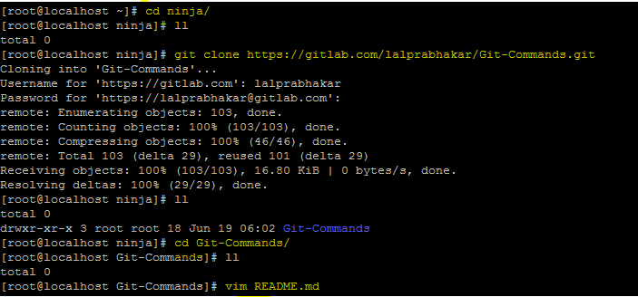



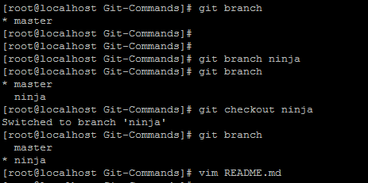

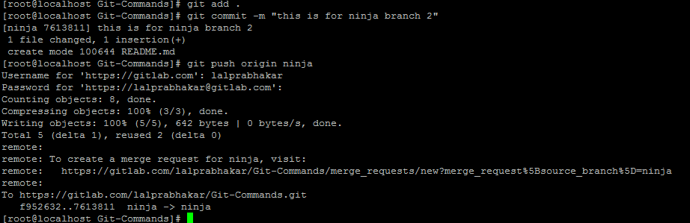

Content in master branch

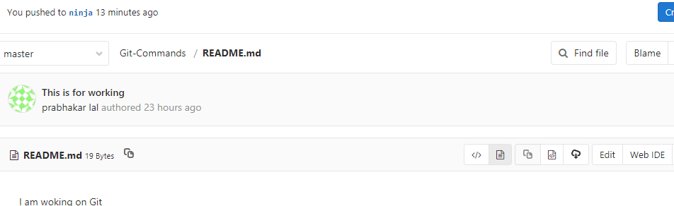

Content in ninja branch

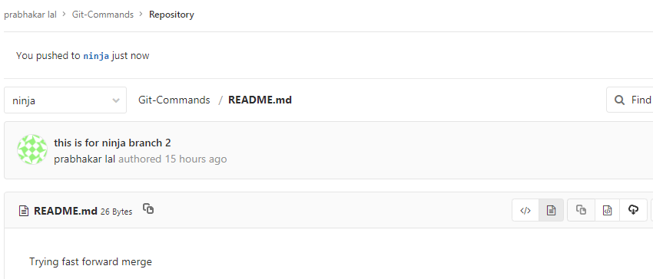

1. Merge ninja branch to master branch make sure that a new commit get's created. Assuming you are in master branch, modify README.md with content Changes in master branch, commit the changes in master branch.

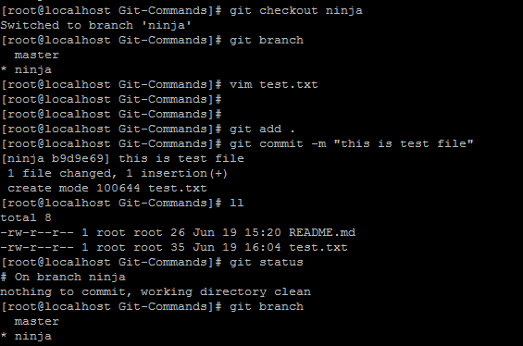

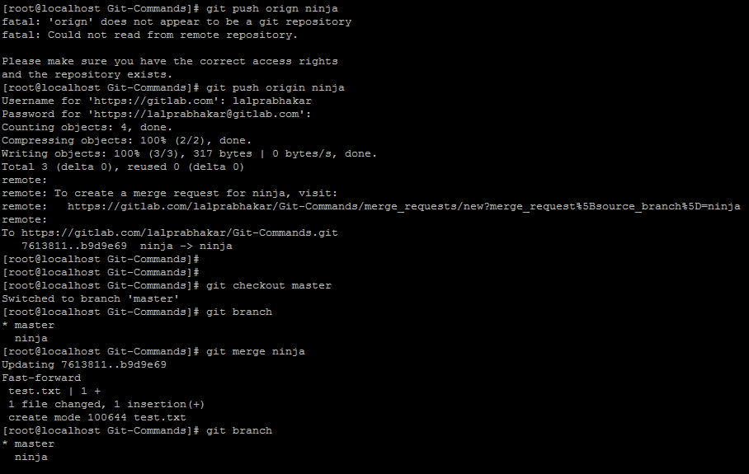

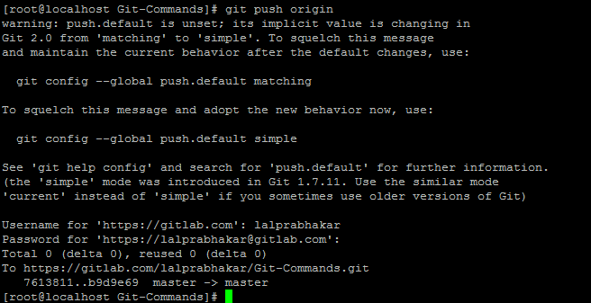

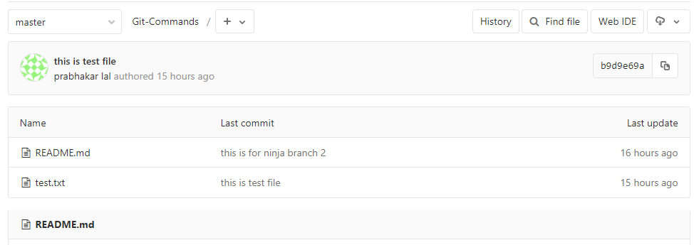

1. Switch to ninja branch, modify README.md with content Changes in ninja branch, commit the changes in ninja branch. Merge master branch to ninja branch in such a fashion that changes of master branch overrides changes in ninja branch

I am able to merge both the branch without any conflict. Given below is snapshot what was performed. My file in master branch got replace with ninja file.

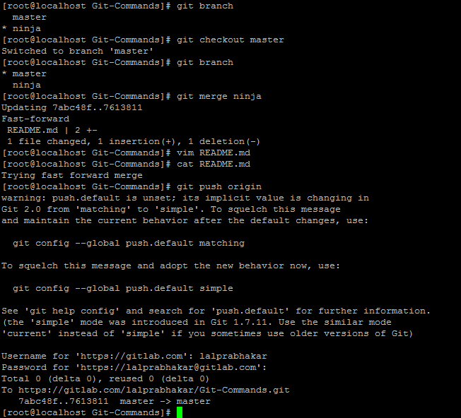

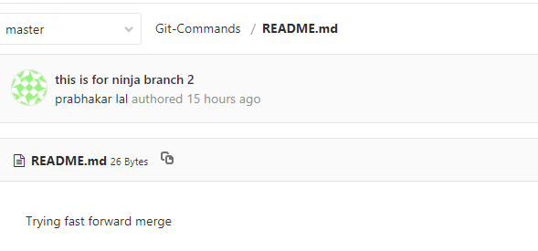

1. Revert the above merge commit

Git revert id<merge/commit> git revert is used to roll back the changes after commit.

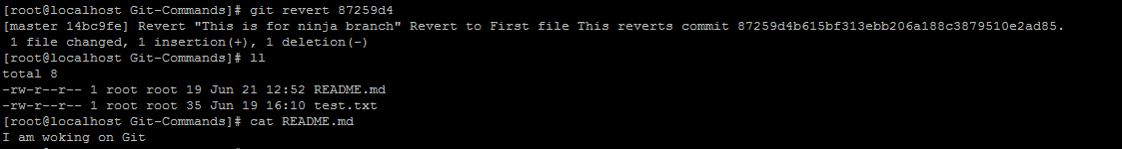

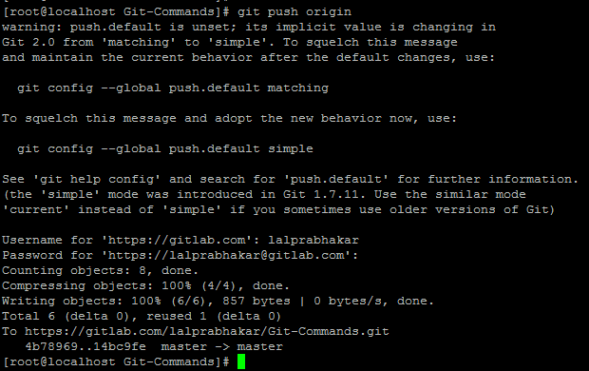

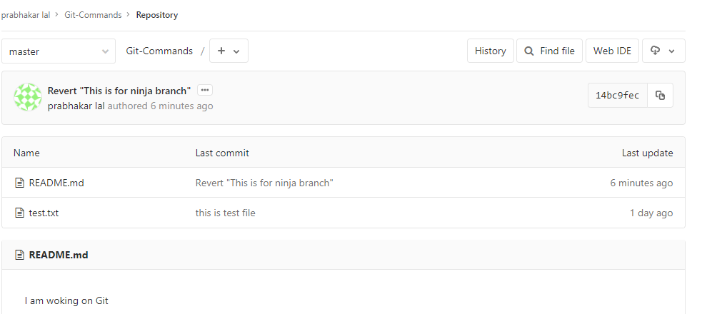

1. Merge master branch to ninja branch in such a fashion that changes of both branches gets accumulated.